Approved by Governors (date) …………………..

Headteacher ………..…………………

On behalf of Governors …………………………..

**Behaviour Management Policy**

At Castle View, we want to create an atmosphere where everyone involved in school is treated with respect, courtesy and fairness, regardless of gender, race, religion, nationality or disability.

We believe good behaviour is essential for personal, social and academic development. It does not happen by accident. It must be nurtured, guided and reinforced and is the responsibility of everyone who is involved in the school community: pupils, staff, parents and governors.

We strive to ensure that we take positive steps to promote high standards of behaviour within the classroom and around the school. At Castle View, we have a restorative approach to deal with incidents of anti-social behaviour or conflict situations. We use this approach because it is very effective in changing the behaviour of those who have harmed others. Punishment on its own is not an effective way of ensuring the children understand the effects of their behaviour on other people. The basic ethos of the restorative approach is to:

* Ensure that children have the opportunity to understand the harm that they have done to others
* Give people who have caused harm reflection time
* Give the people who have caused harm the right to redeem themselves and put things right.

Our aim is to have a fair, consistent system and we, as a school, will strive to ensure that this is achieved. We recognise that on some occasions it may not be possible to establish accurate records of incidents, and therefore, our judgements may require greater flexibility.

We understand that for some children behaviour is communication, therefore, in cases where children’s behaviour cannot be guided through the use of our behaviour system, we will look more in depth at how we can meet their needs.

We believe in promoting positive behaviour beyond the school gates and therefore recognise that our good behaviour systems can also be applied to address certain behaviours that happen outside school.

**Responsibilities of the learners**

***All children are asked to;***

* To **reflect** on their behaviour, be **respectful** and show **resilience.** ARRC (Aspiration, Resilience, Respect, Creativity)
* Talk in a friendly manner to all.
* Follow the rules of the school, the classroom and the playground.
* Work hard, do their best and complete all work set.
* Do as teaching staff, non-teaching staff and parent helpers ask.
* Remember to bring items to school which are needed for that day e.g. PE kits, reading books, homework.
* Leave things at home if they are not **needed** e.g. toys, and small collectable items such as cards and stickers.
* Be honest with staff when incidents occur so that they can be dealt with quickly and options discussed to avoid repetition.
* Come to school in full school uniform and not dress or present themselves in a way which causes distraction, question or offence.

**Responsibilities of Staff**

**School Staff** are defined as any paid member of the school community or any person that the headteacher has temporarily put in charge of pupils such as unpaid volunteers or people accompanying pupils on a school trip.

***All staff are expected to;***

* Promote and model expectations- **respect, reflect and resilience.** ARRC (Aspiration, Resilience, Respect, Creativity)
* Speak with an appropriate tone and model to the children how to speak respectfully.
* Provide interesting and stimulating work, which is well paced and appropriate to each child’s needs.
* Treat all pupils fairly and justly.
* Recognise possible times where inappropriate behaviour may occur and seek avenues to avoid this.
* Praise and reward good work and appropriate behaviour.
* Apply sanctions in a consistent way.
* Support, enable and encourage restorative behaviours.
* Remind children of school rules, rewards and sanctions regularly.
* Encourage appropriate behaviour in class and around school – hold positive values and attitudes and adopt high standards of behaviour in their professional role.
* Encourage children to settle down quickly to work – removing opportunities for fuss and inappropriate behaviour.

**Responsibilities of School Leaders**

The headteacher is responsible for reviewing this behaviour policy and will also approve this policy.

The headteacher will ensure that the school environment encourages positive behaviour and that staff deal effectively with poor behaviour, and will monitor how staff implement this policy to ensure rewards and sanctions are applied consistently.

**Responsibilities of Parents/Carers**

***Parents are requested to;***

* Support the school’s behaviour Policy.
* Work in line with the home-school agreement (see Appendix A)

**Responsibility of Governors**

***Governors oversee the running of the school and try to ensure the needs of the children, the parents, the staff and the LA are met by;***

* Approving the school’s behaviour Policy.
* Monitor the impact of the behaviour Policy.
* Becoming involved in disciplinary action when requested to do so by the Headteacher.

*The* [***Education Act 1996***](http://www.legislation.hmso.gov.uk/acts/acts1996/96056-zj.htm/t_blank#p10c2) *forbids corporal punishment, but allows all teachers to use reasonable force to prevent a pupil from:*

* *committing a criminal offence*
* *injuring themselves or others*
* *damaging property*
* *acting in a way that is counter to maintaining good order and discipline at the school.*

*The Act does not cover more extreme cases, such as action in self-defence or in an emergency, when it might be reasonable for someone to use a degree of force.*

*Staff other than teachers and volunteer helpers are also able to use force if necessary, provided they have been authorised by the head teacher to have control or charge of pupils. People with such authorisation might include teaching assistants, midday supervisors, specialist support assistants, education welfare officers, people accompanying pupils on visits, etc. Head teachers should keep an up-to-date list of authorised people and may find it helpful to provide training or guidance to ensure that everyone is clear on the policy.*

Use of Reasonable Force in School DFE 2013

All members of school staff have a legal power to use reasonable force.

This power applies to any member of staff at the school. It can also apply to people whom the Headteacher has temporarily put in charge of pupils such as unpaid volunteers or parents accompanying students on a school organised visit.

On the rare occasion in which reasonable force is used, this will be logged on the school’s CPOMS system with full details of the incident and recorded in the Bound and Numbered book with details of the incident.

Please see the Use of Force to Reasonably Control or Restrain Pupils.

**We have the following rules, rewards and consequences for learners at Castle View**

Rules

* Do follow directions
* Do walk into and out of school calmly and quietly
* Do keep hands, feet and objects to yourself
* Do not tease, swear or name call or use hurtful terms
* Do use a quiet voice
* Do not damage or steal other people’s property
* Always demonstrate our school values (Ambition, Respect, Resilience, Creativity - ARRC)

Rewards System

* Verbal praise- this should be as explicit as possible
* Provide an achievement badge with an explicit reason
* Praise postcards to be issued by the Headteacher for the recognition of exceptional examples of good behaviour or achievement

‘Good to be Green’ ethos

All children will begin the week on ‘Green’. A green card is displayed in each classroom containing all the children’s names. The aim for the week is to remain on green by always following our good behaviour examples. For any children who have received an achievement badge, who consistently demonstrate exceptional behavior and are excellent role models to others, can be moved to the ‘Gold’ star. These children will also be mentioned by the headteacher in our ‘Good Work Assembly’. Children who are on green or gold by the end of the week, will also access ‘Golden Time’. Children are provided with a range of activities to choose from. Those who are on ‘Gold’ are the first to choose which activity they would like to take part in.

How do we promote and celebrate ‘Green’ behaviour?

***Achievement badges can be earned by pupils exhibiting a good attitude to work, adults, other pupils and general school life. For example;***

* Helping another pupil when they are hurt
* Working co-operatively/sharing
* Helping to prepare the classroom
* Good contributions to class discussion/learning
* Taking responsibility for looking after younger pupils at dinner time or playtime
* Talking kindly to adults and pupils
* Opening doors for others and allowing them to pass through first
* Learning tables
* Scoring well in weekly mental arithmetic
* Working hard- showing resilience.
* Reading at home
* Completing homework
* Having correct PE kit – including change of white t-shirt

*Achievement badges will promote verbal communications between peers and adults and allow for a sense of pride and accomplishment between children, so that children can verbalise and internalise explicitly what they have done well.*

**School Assemblies and Pupil ownership**

At the beginning of each term, school assemblies are held by the headteacher and other school leaders to remind children of our school values (ARRC). Children are encouraged to inform their teachers if they believe another pupil has demonstrated model behaviour. This helps to embed both our values and school rules.

**Restorative approaches**

If children demonstrate inappropriate behaviour, staff will endeavour to adopt an approach which helps the children to recognise what has caused their behaviour. Instead of asking a child ‘why’ they have chosen to behave inappropriately, staff will ask ‘what’ has happened or ‘what’ made them act as they did.

Children who do display ‘yellow’ or ‘red’ behaviour (see section below) are given opportunities to redeem themselves. If their behaviour was an isolated incident and they continue to display ‘green’ behaviour for the rest of the week, they are able to be moved back to green on the behaviour chart. Staff will use professional judgement on determining the seriousness of exhibited behaviours and whether the child(ren) should be able to move on the chart.

Each week, children who exhibit ‘red’ or ‘yellow’ behaviour consistently and remain on ‘yellow’ or ‘red’ by the end of the week, do not access ‘Golden Time’. These children will instead attend reflection time with a member of SLT. During this session, they will discuss their behaviours and why their actions were inappropriate, including why they were unable to redeem themselves over the course of the week. SLT keep a log of children who are missing golden time each week.

If undesirable behaviour continues, SLT will consider the nature of the incident and use appropriate professional judgement to proceed and determine if report cards are necessary.

**What if a child is not following the ‘Good to be Green’ ethos?**

Examples of Yellow behaviour (this is not an exhaustive list)

* Running in school
* Talking in assembly or singing
* Talking whilst the teacher is talking
* Talking when lining up
* Talking when you should be working silently
* Loss of equipment
* Shouting in School
* Not raising hand to speak when it has been made clear to do so
* Failing to line up when asked or, where appropriate, in the correct order
* Disrespectfully talking back to adults and others
* Chewing in school (gum)
* Name calling
* Play fighting
* Swearing
* In school during break times without permission

If children exhibit any of the ‘Yellow’ behaviours, their name is removed from the green card and placed onto a yellow card. This card is kept in the teacher behavour file and is not displayed in the classroom. The teacher will also log the reason why the child has been moved to yellow on their individual behaviour sheet, also kept in the teacher’s behaviour file. If low -level behaviour continues, with no improvement after use of a personalised behaviour chart and regular discussions with the child and parents, a monitoring report may be issued.

The teacher will discuss with the child what led to their behaviour and will explain they have an opportunity to redeem themselves. If the child exhibits excellent behaviour for the remainder of the week, they may be moved back to ‘green’.

Examples of Red behaviour (this is not an exhaustive list)

* Being removed from class or being placed into the resources room
* Violence
* Aggressive behaviour
* Throwing things in class
* Defacing own or others work
* Spitting
* Defiance – refusal to do as asked- after warnings
* Answering back to staff and behaving disrespectfully
* Throwing food in the dinner hall
* Threatening behavior or making threats
* Harmful sexual behaviour
* Sexual harassment
* Issues of consent
* Any other safeguarding risks

If children exhibit any of the ‘Red’ behaviours, their name is removed from the green/ yellow card and placed onto a red card. This card is also kept in the teacher behaviour file and is not displayed in the classroom. Again, the teacher will log the reason why the child has been moved to red on their individual behaviour sheet.

The teacher will again discuss with the child what led to their behaviour and that they still have an opportunity to redeem themselves. If the child exhibits excellent behaviour for the remainder of the week, they can be moved to ‘yellow’ and then back to ‘green’. For some incidents, parents may also be contacted. Depending on the severity of the ‘red’ behaviour, the child may have a discussion with Mrs Williams (child well being designated member of staff) or Mrs Wright (SEAL group leader), to ensure children feel supported and recognise how to cope with their behaviour and make better choices in the future.

Teachers will ensure any issues involving sexual harassment or issues of consent are discussed with the child, parents and also reported to the Designated Safeguarding Lead. Children are educated at age appropriate levels on abuse, online abuse and any incidents regarding violence or conflict. Sessions are taught both in PSHE lessons and in whole school assemblies.

**\*\*All staff are fair and consistent in deciding if children should be moved to yellow or red.**

If any child exhibits bullying behaviours, we have a zero tolerance approach to bullying and members of staff will deal with each incident using appropriate professional judgement. Please see our anti bullying policy for more information.

**Children who are still remaining on yellow or red at the end of the week, who have not restored their behaviour, lose their entitlement to an end of week rewards (chocolate treat and golden time).**

Records are kept for forgetting home reading book on required day, but this does not affect the behaviour chart. If a home reading book is not brought in more than three times, then this must be discussed with parents by the class teacher.

Records are kept for failing to complete homework on time, but also does not affect the behaviour chart. Children must complete homework in homework club at lunch time. If a child hasn’t brought their homework more than 4 times, then the teacher must discuss this as an issue with the parent and seek to encourage completion of this at home. Teachers must use their discretion regarding reasons for not bringing homework in.

Records are kept for failing to bring PE kit including a change of t-shirt.

**Off-site behaviour**

Sanctions may be applied where a pupil has misbehaved off-site when representing the school, such as on a school trip or on the bus on the way to or from school. This includes the right to exclude a pupil for behaviour that has taken place off-site but may have a detrimental impact on the management of the school.

**Malicious allegations**

Where a pupil makes an accusation against a member of staff and that accusation is shown to have been malicious, the headteacher will discipline the pupil in accordance with this policy.

Please refer to our safeguarding policy for dealing with allegations of abuse against staff for more information on responding to allegations of abuse.

The headteacher will also consider the pastoral needs of staff accused of misconduct***.***

**Playground Rules**

Do follow instructions

Do walk into and out of school calmly and quietly

Do keep hands, feet and objects to yourself

Do not climb on the MUGA frame

Do not call anyone hurtful names, swear or spit

Do use the toilets properly – children are encouraged to use the toilet at break time and not in lesson time

*Stop moving/stand still on the first whistle – calmly walk into school on the second.*

**Violent behaviour, kicking, fighting**

First Incident – 1 day removal from playtime, dinner in a separate area and moved to ‘red’.

Second incident – 3 days removal from playtimes and dinner in a separate area and again moved to ‘red’ (using only 1 line on their behaviour sheet – this must also be highlighted by the teacher as an act of violence)

**Parents informed of behaviour verbally**

Third Incident - 5 days removal from playtimes and dinner in a separate area and use of school monitoring report (using only 1 line on their behaviour sheet – this must also be highlighted by the teacher)

**Parents involved in discussion of next steps verbally and by letter School monitoring report issued.**

Further Incident - 5 days removal from playtimes and dinner in a separate area and use of full school report card (using only 1 line on their behaviour sheet – this must also be highlighted by the teacher)

**Parents involved in discussion of next steps- Full school report and behaviour plan issued.**

Violent incidents will be recorded in the behaviour log and on CPOMS to monitor episodes of violence.

With children who are moved to red for violence, staff will talk with them about their behaviour and discuss strategies to promote positive behaviour.

**The behaviour log will be stored in the Headteacher’s office for secure keeping and must be returned after use.**

**Full School Report Card**

When a child has been moved to red three times due to violence, they will first be placed on a monitoring report card. This will provide a review period where their behaviour will be monitored and strategies will be put in place with the child to support them to prevent further incidents.

If a child is moved to red three times under any circumstance, parents will be informed and the pupil may be placed on a monitoring or full school report card. This will be decided based on the needs of the pupil and on a case by case basis.

At this stage, there may be an agreement to adjust some of the school routines and privileges in the best interest of the child.

The report card will keep a more detailed log of the child’s behaviour during each session of the day. This will be shared daily with the Headteacher or Deputy Headteacher and signed by them.

If there is no improvement in the pupil’s behaviour after 3 weeks on report, parents are informed again and a decision as to whether the child would benefit from an additional support plan and further action may be taken. If there is an improvement, pupils will be taken off the green report card.

The school SENCO and class teacher may make a decision to draw on the support of other agencies to support children who are continuously disruptive in school. This would be discussed with parents prior to seeking outside agency support.

A pupil who has been placed onto report may be excluded from class visits or class privileges. However, these sanctions may be lifted if an individual behaviour plan deems that these activities may be beneficial.

For some children, we recognise that the report card system may not meet their individual behaviour improvement needs. Therefore, we may introduce other recording systems that will endeavour to support their move back towards positive and appropriate behaviour.

**Pupil support**

The school recognises its legal duty under the Equality Act 2010 to prevent pupils with a protected characteristic from being at a disadvantage. Consequently, our approach to challenging behaviour may be differentiated to cater to the needs of the pupil.

The school’s special educational needs co-ordinator will evaluate a pupil who exhibits challenging behaviour to determine whether they have any underlying needs that are not currently being met.

Where necessary, support and advice will also be sought from specialist teachers, an educational psychologist, medical practitioners and/or others, to identify or support specific needs.

When acute needs are identified in a pupil, we will liaise with external agencies and plan support programmes for that child. We will work with parents to create the plan and review it on a regular basis.

**Conduct and Behaviour of Parents on the school premises**

The governing body at Castle View School will not tolerate inappropriate and abusive behaviour of any parents on the school property. Procedures are in place to allow children a safe, calm and settled entrance into their classrooms at the start of the school day and also from the school premises at the end of the school day. Any parents seen to be abusing this system with violent or abusive behaviour may be excluded from the school premises and grounds for a fixed period of time, or on a permanent basis if deemed necessary to safeguard the children and staff.

The school takes the well-being and safety of all pupils and staff extremely seriously.

Section 547 of the Education Act 1996 makes it a criminal offence;

*For a person to be present at an educational premises without lawful authority*

*and to cause or permit nuisance or disturbance to the annoyance of the persons who lawfully use the premises.*

***Please Note*, certain behaviours may lead to a pupil being excluded from school (see exclusions policy).**

**Although this rarely occurs, please note that if children leave the school or run out of school during the day the Police are informed. It is too dangerous for children to abscond.**

See also Exclusions Policy, Anti-Bullying Policy and Use of Force to Restrain Pupils Policy

**Castle View staff have the right to screen and search any pupils with consent. They also have the right to search pupils without consent if they suspect that the pupil is carrying any prohibited item without consent such as:**

* knives and weapons
* alcohol
* illegal drugs
* stolen items
* tobacco and cigarette papers
* fireworks
* any article that has been or is likely to be used to commit an offence, cause personal injury or damage to property; and
* any item banned by the school rules which has been identified in the rules as an item which may be searched for (e.g. telephones, electronic equipment, toys, items stored in a place not permitted e.g. PE kits, lunchboxes, coats, trays, bags).

**Pupil transition**

To ensure a smooth transition to the next year, pupils have transition sessions with their new teacher(s). In addition, staff members hold transition meetings.

To ensure behaviour is continually monitored and the right support is in place, information related to pupil behaviour issues may be transferred to relevant staff at the start of the term or year. Information on behaviour issues may also be shared with new settings for those pupils transferring to other schools.

**Training**

Our staff are provided with training on managing behaviour, including proper use of restraint, as part of their induction process.

Behaviour management will also form part of continuing professional development.

Reviewed and updated September 2024

Appendix A 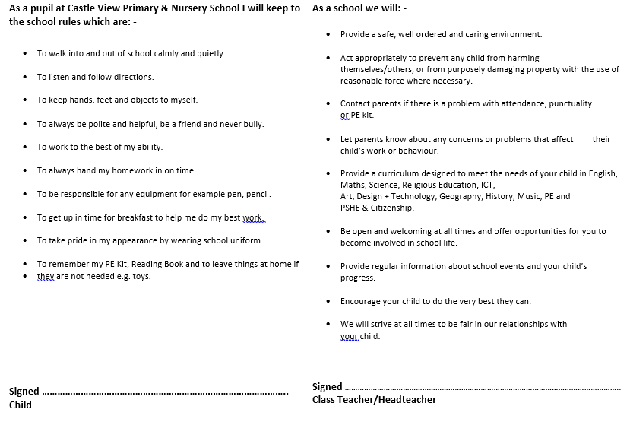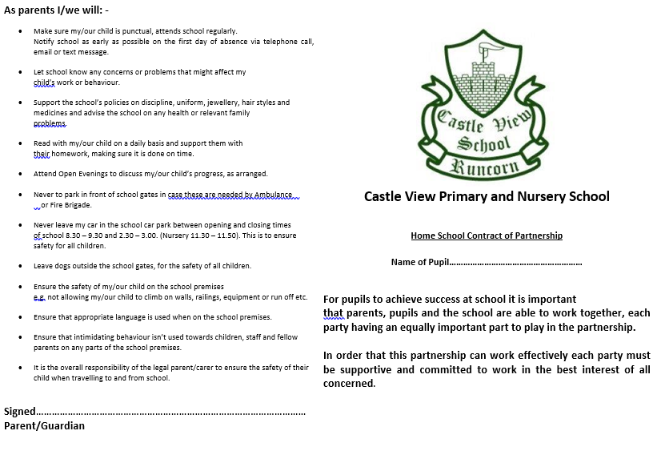

Appendix B –

Dear parent,

Recently, your child, _____________________________, has not been behaving as well in school as they could.

It is important that your child understands the need to follow our pupil code of conduct, and I would appreciate it if you could discuss their behaviour with them.

If your child’s behaviour does not improve, I will contact you again and suggest that we meet to discuss how we can work together. However, at this stage I am confident that a reminder of how to behave appropriately will be sufficient.

Yours sincerely,

Class teacher name:

Class teacher signature:

Date:

-----------------------------------------------------------------------------------------------------------------

**Behaviour letter – return slip**

Please return this slip to school to confirm you have received this letter. Thank you.

Name of child:

Parent name:

Parent signature:

Date: